­Multiple choice section

|  |  |  |  |  |  |  |  |  |  |  |
| --- | --- | --- | --- | --- | --- | --- | --- | --- | --- | --- |
| Question | 1 | 2 | 3 | 4 | 5 | 6 | 7 | 8 | 9 | 10 |
| Answer | B | A | D | D | A | B | C | B | D | A |

Question 1 [8.2]

B

Angles between 0° and 90° are acute angles

Question 2 [8.2]

A

100° is an obtuse angle.

Question 3 [8.2]

D

Complementary angles add to 90°.

Question 4 [8.6]

D

All three sides & all 3 angles are equal for an equilateral triangle.

Question 5 [8.3]

C

Vertically opposite angles are equal.

Question 6 [8.5]

B

The shape is a concave quadrilateral.

Question 7 [8.4]

B

Angles a and b are co-interior.

Question 8 [8.6]

B

The triangle is isosceles.

Question 9 [8.5]

D

This polygon has 8 sides so is an octagon.

Question 10 [8.4]

A

Angle y and 110° are corresponding angles.

Multiple-choice total marks: 10

Short answer section

Question 11 1 marks [8.1]

60°

Question 12 2 marks [8.1]

(a) 55° (b) 150° (c) ∠EAR

Question 13 4 marks [8.1]

(a)

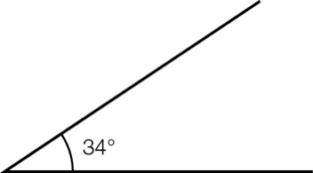

(b)   
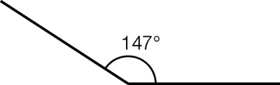

Question 14 3 marks [8.2]

(a) straight angle

(b) acute angle

(c) revolution

Question 15 3 marks [8.2]

(a) right angle

(b) obtuse angle

(c) reflex angle

Question 16 3 marks [8.2]

(a) Complementary angles add to 90°.  
3 + 87 = 90

(b) Supplementary angles add to 180°.  
105 + 85 = 180

(c) Neither angles add to 260°.  
180 + 80 = 260

Question 17 3 marks [8.3]

x + 35 + 115 = 180 (supplementary angles add to 180°)

x = 180° – 150°

x = 30°

Question 18 3 marks [8.3]

x + 129 + 51 + 140 = 360 (angles in a revolution)

x + 320 = 360

x = 40°

Question 19 1 marks [8.4]

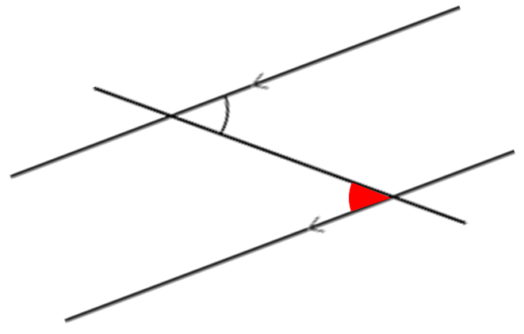

(alternate angle marked in red)

Question 20 2 marks [8.4]

x + 62 = 180

x = 118°

(co-interior angles on parallel lines)

Question 21 4 marks [8.5]

Triangles, square, hexagon and dodecagon

Question 22 4 marks [8.6]

|  |  |
| --- | --- |
| (a) x + 50 + 100 = 180 (angle sum in a triangle) x + 150 = 180 x = 30° | (b) x + x + 54 = 180 (angles in an isosceles triangle) 2x + 54 = 180 (angle sum of a triangle) 2x = 126 x = 63° |

Question 23 2 marks [8.6]

x = 117 + 43

(exterior angle of a triangle)

x = 160°

Question 24 3 marks [8.8]

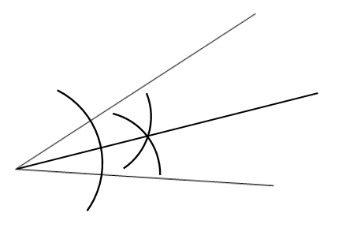

Question 25 3 marks [8.5]

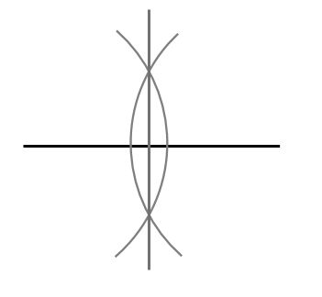 Short answer total: 41

Extended answer section

Question 26 5 marks [8.7]

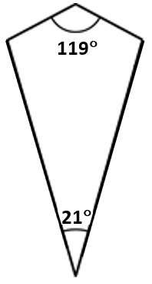

x + x + 119 + 21 = 360

2x + 140 = 360

(angle sum of a quadrilateral)

(opposite angles in a kite are equal)

2x = 220

x = 110°

Question 27 6 marks [8.7]

21 + 3x = 90

(complementary angles add to 90°)

3x = 69

x = 23°

Question 28 5 marks [8.7]

(a) x + 45 + 105 + 155 = 360

(b) x + 305 = 360  
x = 55°

Extended answer total: 16

TOTAL test marks: 67